Section 6-1: Proportions

SOL: None

Objective:
Write ratios
Use properties of proportions

Vocabulary:
Ratio: a comparison of two quantities (a:b)
Proportion: an equation stating that two ratios are equal
Extremes of the proportion: the outer numbers in the proportion
Means of the proportion: the inner numbers in the proportion
Cross product of means = to cross product of extremes

Key Concept:
Property of Proportions: for any numbers a and c and any nonzero numbers b and d,

a c
--- = --- if and only if, ad = bc
b d

Example 1:
- The total number of students who participate in sports programs at Central High School is 520. The total number of students in the school is 1850. Find the athlete-to-student ratio to the nearest tenth.

- The country with the longest school year is China with 251 days. Find the ratio of school days to total days in a year for China to the nearest tenth. (Use 365 as the number of days in a year.)

Example 2:
- In a triangle, the ratio of the measures of three sides is 5:12:13, and the perimeter is 90 centimeters. Find the measure of the shortest side of the triangle.
A 15 cm B 18 cm C 36 cm D 39 cm

- In a triangle, the ratio of the measures of three sides is 3:4:5, and the perimeter is 42 feet. Find the measure of the longest side of the triangle.
A 10.5 ft B 14 ft C 17.5 ft D 37 ft

Example 3: Solve the following
6 9
- ----- = ------
18.2 y

13.5 b
- ------- = ------
42 14

7n – 1 15.5
- --------- = --------
8 2

Example 4:
- A boxcar on a train has a length of 40 feet and a width of 9 feet. A scale model is made with a length of 16 inches. Find the width of the model.

- Two large cylindrical containers are in proportion. The height of the larger container is 25 meters with a diameter of 8 meters. The height of the smaller container is 7 meters. Find the diameter of the smaller container.

Concept Summary:
A ratio is a comparison of two quantities
A proportion is an equation stating that two ratios are equal

Reading Assignment: read section 6-2

Homework: pg 285-6: 4, 10, 13, 14, 18, 21, 28-31
Section 6-2: Similar Polygons

SOL: G.14 The student will use proportional reasoning to solve practical problems, given similar geometric objects; and

Objectives:
Identify similar figures
Solve problems involving scale factors

Vocabulary:
Scale factor – the ratio of corresponding sides of similar polygons

Key Concept:
Similar Polygons: Two polygons are similar if and only if their corresponding angles are congruent and the measures of their corresponding sides are proportional

Concept Summary:
In similar polygons, corresponding angles are congruent, and corresponding sides are in proportion
The ratio of two corresponding sides in two similar polygons is the scale factor

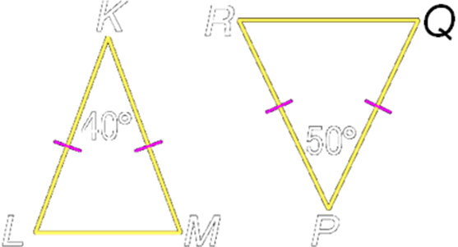
Example 1a: Determine whether the pair of figures is similar. Justify your answer.

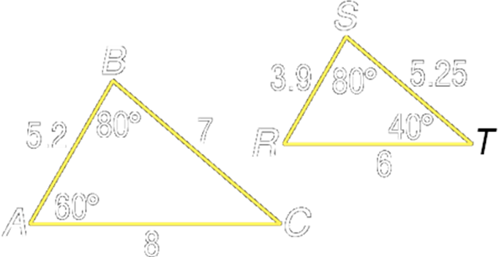
Example 1b: Determine whether the pair of figures is similar.
Justify your answer.

Example 1c: Determine whether the pair of figures is similar. Justify your answer.
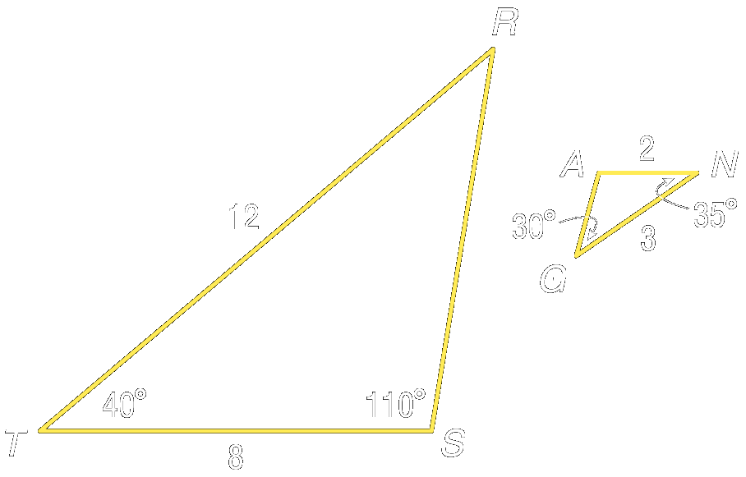

Example 2a: An architect prepared a 12-inch model of a skyscraper to look like a real 1100-foot building. What is the scale factor of the model compared to the real building?

Example 2b: A space shuttle is about 122 feet in length. The Science Club plans to make a model of the space shuttle with a length of 24 inches. What is the scale factor of the model compared to the real space shuttle?

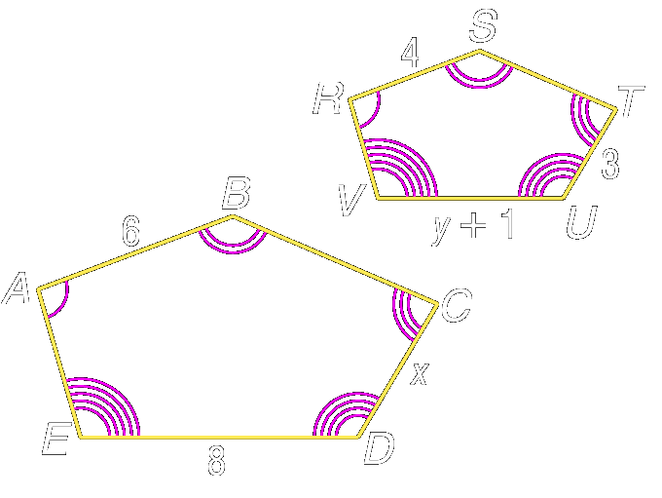
Example 3a: The two polygons are similar. Write a similarity statement. Then find x, y, and UV.

Example 3b: The two polygons are similar. Find the scale factor of polygon ABCDE to polygon RSTUV.

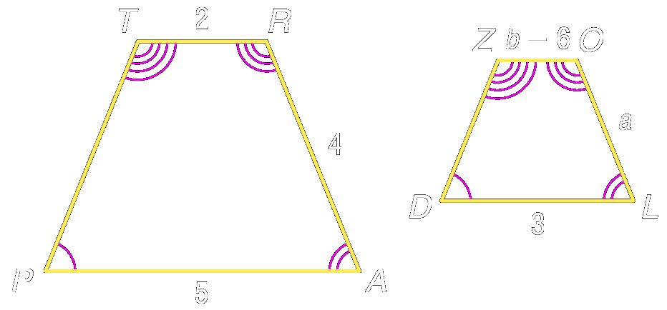
Example 3c: The two polygons are similar.
a. Write a similarity statement, then find a, b, and ZO.

b. Find the scale factor of polygon TRAP to polygon ZOLD.

Reading Assignment: read section 6-3

Homework: pg 293-5: 4, 6, 7, 12, 13, 27-31, 36, 38
Section 6-3: Similar Triangles

SOL: G.5 The student will
a) investigate and identify congruence and similarity relationships between triangles; and
b) prove two triangles are congruent or similar, given information in the form of a figure or statement, using algebraic and coordinate as well as deductive proofs

Objective:
Identify similar triangles
Use similar triangles to solve problems

Vocabulary: None new

Theorems:

Postulate 6.1: Angle-Angle (AA) Similarity
If two angles of one triangle are congruent to two angles of another triangle,
then the triangles are similar

Theorem 6.1: Side-Side-Side (SSS) Similarity
If all the measures of the corresponding sides of two triangles are proportional,
then the triangles are similar

Theorem 6.2: Side-Angle-Side (SAS) Similarity
If the measures of two sides of a triangle are proportional to the measures of two corresponding side of another triangle and the included angles are congruent,
then the triangles are similar

Theorem 6.3: Similarity of triangles is reflexive, symmetric, and transitive
Reflexive: ∆ABC ~ ∆ABC
Symmetric: If ∆ABC ~ ∆DEF, then ∆DEF ~ ∆ABC
Transitive: If ∆ABC ~ ∆DEF and ∆DEF ~ ∆GHI, then ∆ABC ~ ∆GHI

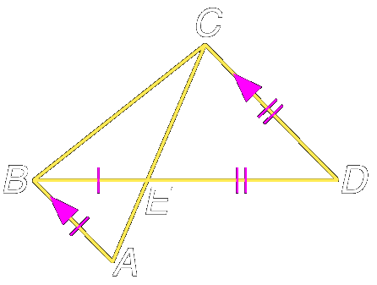
Example 1a: In the figure, AB // DC, BE = 27, DE= 45, AE = 21, and CE = 35. Determine which triangles in the figure are similar.

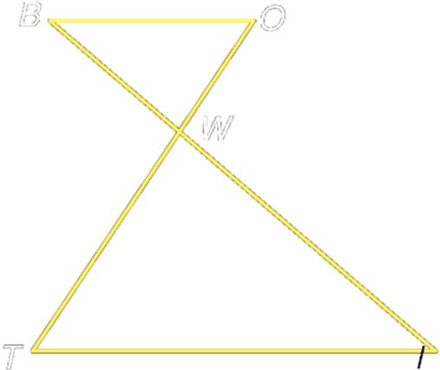
Example 1b: In the figure, OW = 7, BW = 9, WT = 17.5, and WI = 22.5. Determine which triangles in the figure are similar.

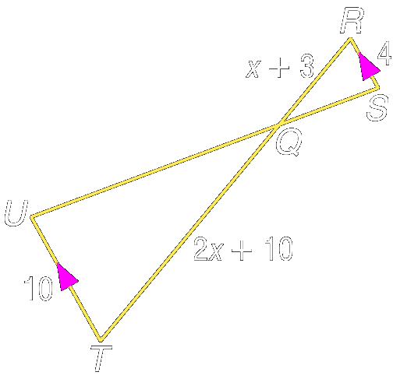
Example 2a: Given RS // UT, RS=4, RQ=x+3, QT=2x+10, UT=10, find RQ and QT

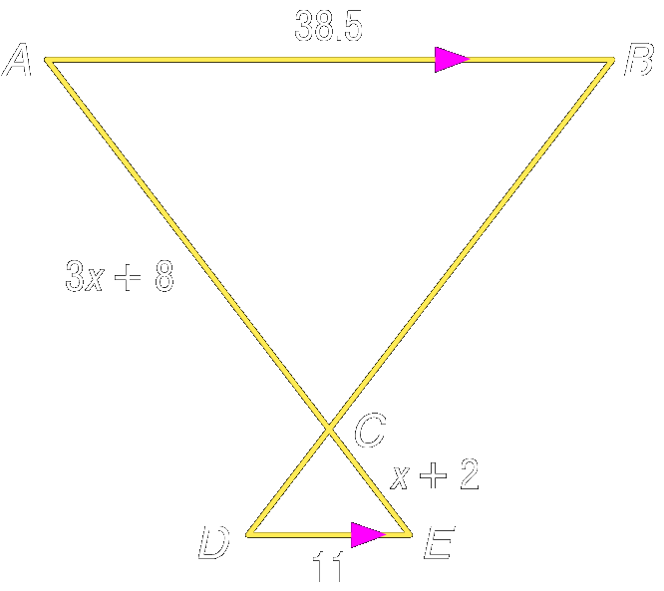
Example 2b: Given AB // DE, AB=38.5, DE=11, AC=3x+8, and CE=x+2, find AC and CE.

Example 3a: Josh wanted to measure the height of the Sears Tower in Chicago. He used a 12-foot light pole and measured its shadow at 1 P.M. The length of the shadow was 2 feet. Then he measured the length of the Sears Tower’s shadow and it was 242 feet at that time. What is the height of the Sears Tower?

Example 3b: On her trip along the East coast, Jennie stops to look at the tallest lighthouse in the U.S. located at Cape Hatteras, North Carolina. At that particular time of day, Jennie measures her shadow to be 1 feet 6 inches in length and the length of the shadow of the lighthouse to be 53 feet 6 inches. Jennie knows that her height is 5 feet 6 inches. What is the height of the Cape Hatteras lighthouse to the nearest foot?

Concept Summary:
AA, SSS and SAS Similarity can all be used to prove triangles similar
Similarity of triangles is reflexive, symmetric, and transitive

Reading Assignment:
Day 1: reread section 6-3
Day 2: read section 6-4

Homework:
Day 1: pg 301-302: 6-8, 11-15
Day 2: pg 301-305: 9, 18-21, 31
Section 6-4: Parallel Lines and Proportional Parts

SOL: None

Objective:
Use proportional parts of triangle
Divide a segment into parts

Vocabulary:
Midsegment: a segment whose endpoints are the midpoints of two sides of the triangle

Key Concept: Nonparallel transversals that intersect parallel lines can be extended to form similar triangles. So the sides of the triangles are proportional.

Theorems:

Theorem 6.4: Triangle Proportionality Theorem:
If a line is parallel to one side of a triangle and intersects the other two sides in two distinct points, this it separates these sides into segments of proportional lengths.
Theorem 6.5: Converse of the Triangle Proportionality Theorem:
If a line intersects two sides of a triangle and separates the sides into corresponding segments of proportional lengths, then the line is parallel to the third side
Theorem 6.5: Triangle Midsegment Theorem:
A midsegment of a triangle is parallel to one side of the triangle, and its length is one-half the length of that side.

Corollaries:

  - If three or more parallel lines intersect two transversals, then they cut off the transversals proportionally
  - If three or more parallel lines cut off congruent segments on one transversal, then they cut off congruent segments on every transversal

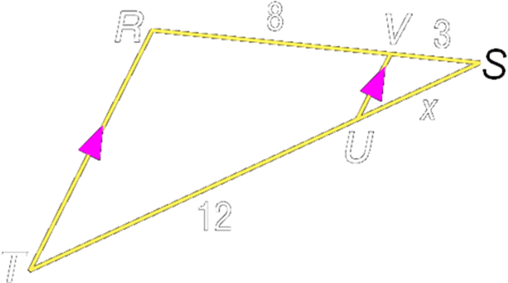
Example 1a: In ∆RST, RT // VU, SV = 3, VR = 8, and UT = 12. Find SU.

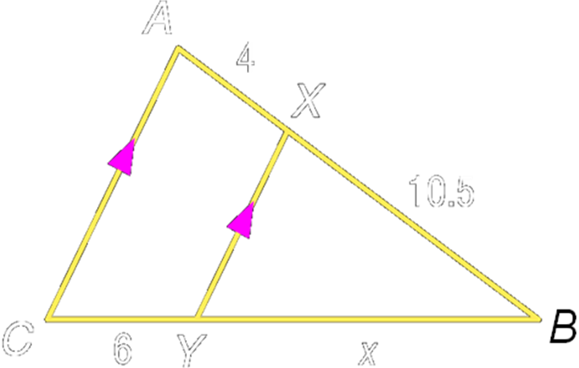
Example 1b: In ∆ABC, AC // XY, AX=4, XB=10.5 and CY=6. Find BY.

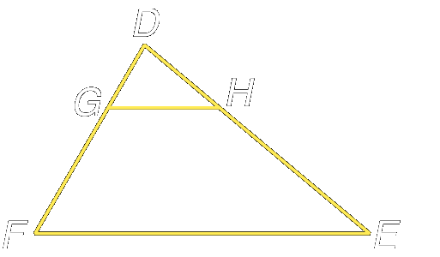
Example 2a: In ∆DEF, DH=18, HE=36, and 2DG = GF. Determine whether GH // FE. Explain.

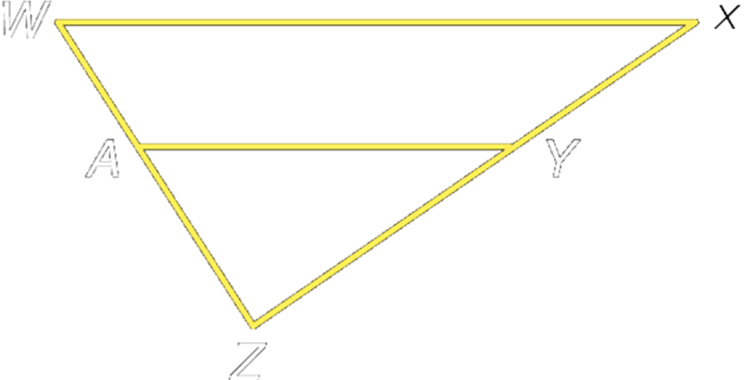
Example 2b: In ∆WXZ, XY=15, YZ=25, WA=18 and AZ=32. Determine whether WX // AY. Explain.

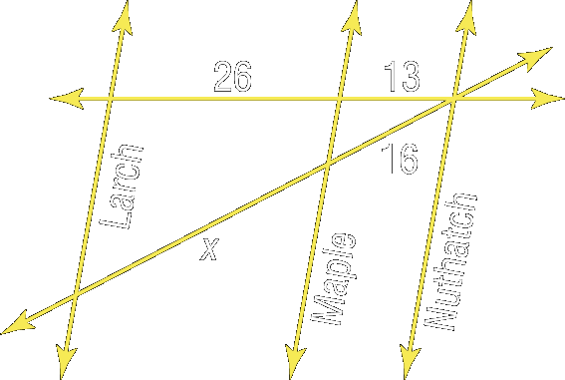
Example 3a: In the figure, Larch, Maple, and Nuthatch Streets are all parallel. The figure shows the distances in city blocks that the streets are apart. Find x.

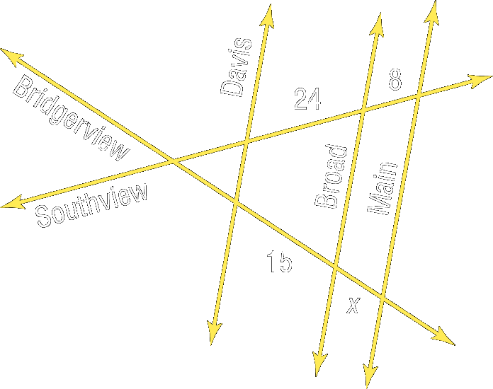
Example 3b: In the figure, Davis, Broad, and Main Streets are all parallel. The figure shows the distances in city blocks that the streets are apart. Find x.

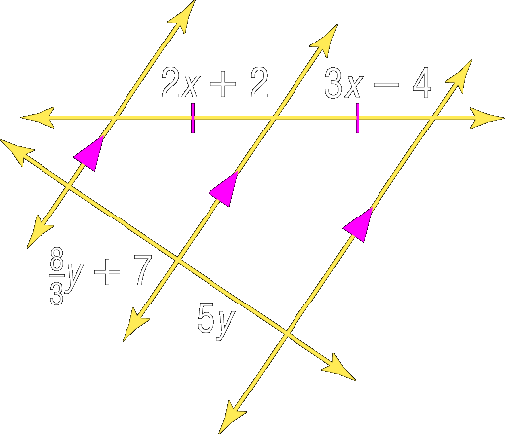
Example 4a: Find x and y.

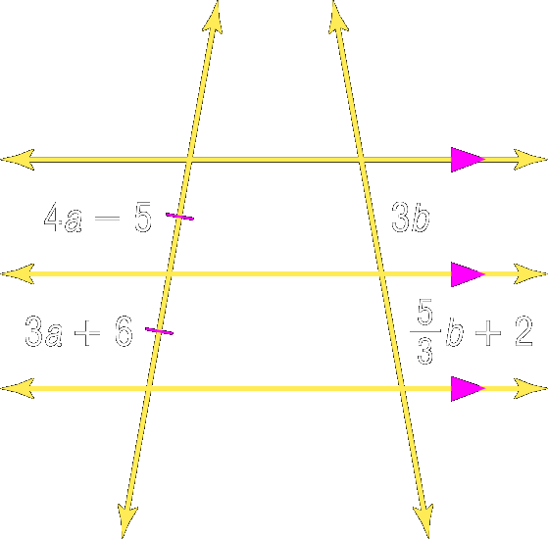
Example 4b: Find a and b.

Concept Summary:
A segment that intersects two sides of a triangle and is parallel to the third side divides the two intersected sides in proportion
If two lines divide two segments in proportion, then the lines are parallel

Reading Assignment:
Day 1: reread section 6-4
Day 2: read section 6-5

Homework: Day 1: pg 311-2: 9, 10, 14-18
Day 2: pg 312-3: 11, 12, 20, 21, 23-26, 33, 34
Section 6-5: Parts of Similar Triangles

SOL:
G.5: The student will
a) investigate and identify congruence and similarity relationships between triangles;
G.14 The student will
a) use proportional reasoning to solve practical problems, given similar geometric objects;

Objective:
Recognize and use proportional relationships of corresponding perimeters of similar triangles
Recognize and use proportional relationships of corresponding angle bisectors, altitudes, and medians of similar triangles

Vocabulary: None New

Theorems:

Theorem 6.7: Proportional Perimeters Theorem: If two triangles are similar, then the perimeters are proportional to the measures of corresponding sides

Special Segments of Similar Triangles:
Theorem 6.8: If two triangles are similar, then the measures of the corresponding altitudes are proportional to the measures of the corresponding sides
Theorem 6.9: If two triangles are similar, then the measures of the corresponding angle bisectors of the triangles are proportional to the measures of the corresponding sides
Theorem 6.10: If two triangles are similar, then the measures of the corresponding medians are proportional to the measures of the corresponding sides

Theorem 6.11: Angle Bisector Theorem: An angle bisector in a triangle separates the opposite side into segments that have the same ratio as the other two sides

Concept Summary:
Similar triangles have perimeters proportional to the corresponding sides
Corresponding angle bisectors, medians, and altitudes of similar triangles have lengths in the same ratio as corresponding sides
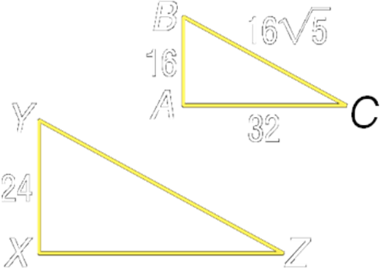
Example 1a: If ∆ABC~∆XYZ, AC=32, AB=16, BC=16√5, and XY=24, find the perimeter of ∆XYZ

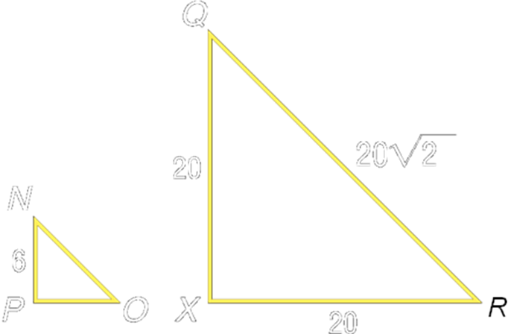
Example 1b: If ∆PNO~∆XQR, PN=6, XQ=20, QR=20√2, and RX = 20, find the perimeter of ∆PNO

Example 2a: ∆ABC ~∆MNO and 3BC = NO. Find the ratio of the length of an altitude of ∆ABC to the length of an altitude of ∆MNO.

Example 2b: ∆EFG~∆MSY and 4EF = 5MS. Find the ratio of the length of a median of ∆EFG to the length of a median of ∆MSY.

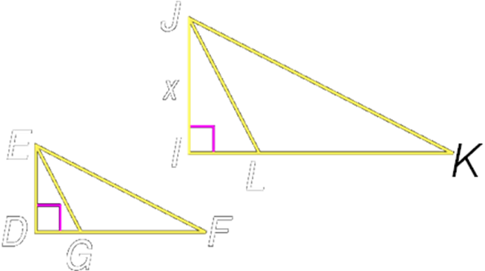
Example 3a: In the figure, ∆EFG~ ∆JKL, ED is an altitude of ∆EFG and JI is an altitude of ∆JKL. Find x if EF=36, ED=18, and JK=56.

Example 3b: In the figure, ∆ABD ~ ∆MNP and AC is an altitude of ∆ABD and MO is an altitude of ∆MNP. Find x if AC=5, AB=7 and MO=12.5
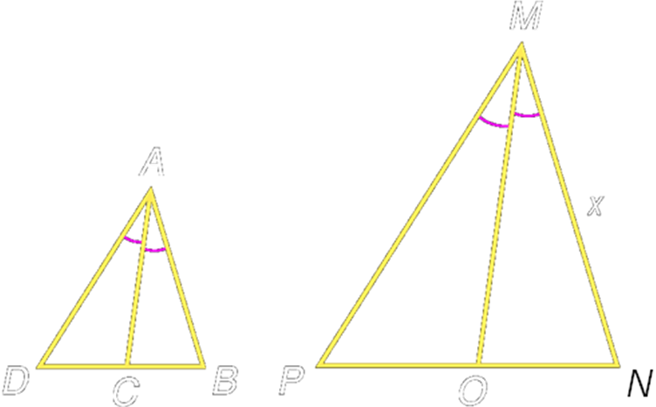

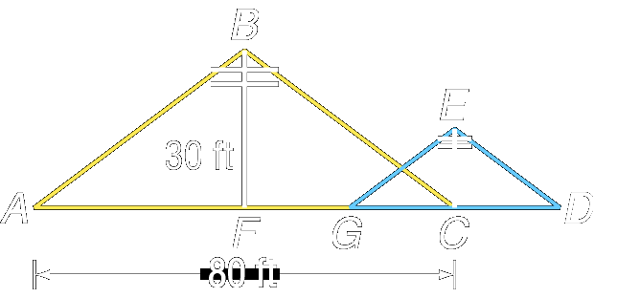
Example 4: The drawing below illustrates two poles supported by wires with ∆ABC~∆GED, AF≅CF, and FG≅GC≅ DC. Find the height of the pole EC.

Reading Assignment:
Day 1: reread section 6-5
Day 2: read section 6-6

Homework: Day 1: pg 319-20: 3-7, 11-15
Day 2: pg 320-21: 17-19, 22-24,
Section 6-6: Fractals and Self-Similarity

SOL: None.

Objective:
Recognize and describe characteristics of fractals
Identify nongeometric iteration

Vocabulary:
Iteration – the process of repeating the same procedure over and over again
Fractal – a geometric figure that is created using iteration. The pattern’s structure appears to go on infinitely
Self similar – the smaller and smaller details of a shape have the same geometric characteristics as the original form
Recursive formulas – iterative process that has been translated into formulas or algebraic equations

Concept Summary:
Iteration is the creation of a sequence by repetition of the same operation
A fractal is a geometric figure created by iteration
An iterative process involving algebraic equations is a recursive formula

Reading Assignment: reread Chapter 6

Homework: pg 331: 48-54

Fractal Example



Lesson 6-2
- There are 480 sophomores and 520 juniors in a high school. Find the ratio of juniors to sophomores.

- A strip of wood molding that is 33 inches long is cut into two pieces whose lengths are in the ratio of 7:4. What are their lengths?

Solve each proportion.

3. 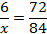 4. 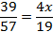 5. 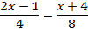

6. The ratio of the measures of the three angles of a triangle is 13:6:17. Find the measure of the largest angle.

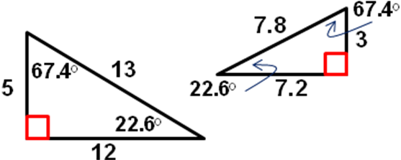
Lesson 6-3
- Determine whether the triangles are similar. Justify your answer.

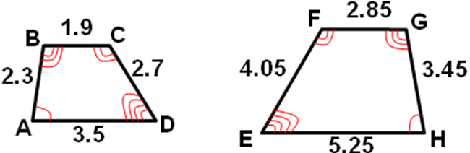
- The quadrilaterals are similar. Write a similarity statement and find the scale factor of the larger to the smaller quadrilateral.

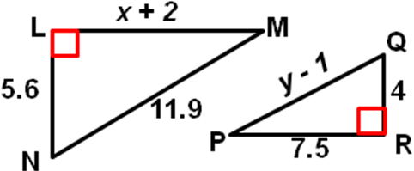

- The triangles are similar. Find x and y.

- Which one of the following statements is always true?
  - Two rectangles are similar
  - Two right triangles are similar
  - Two acute triangles are similar
  - Two isosceles right triangles are similar

Lesson 6-4
Determine if each pairs of triangles are similar. If so, write a similarity statement. Justify your statement.
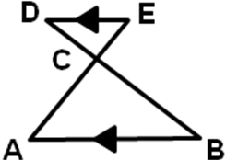
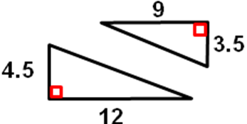
- 2.

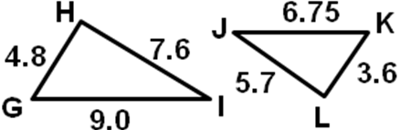
3.

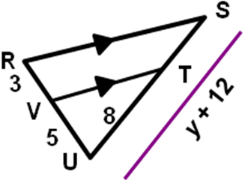

4. In the figure below, if RS // VT, then find y.
Lesson 6-5
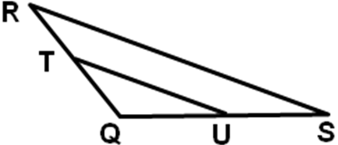
Refer to the figure
- If QT = 5, TR = 4, and US = 6, find QU.

- If TQ = x + 1, TR = x – 1, QU = 10 and QS = 15, find x.

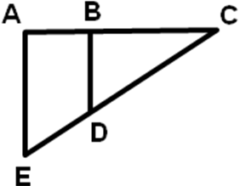
Refer to the figure
- If AB = 5, ED = 8, BC = 11, and DC = x – 2,
find x so that BD // AE.

- If AB = 4, BC = 7, ED = 5, and EC = 13.75, determine whether
BD // AE.
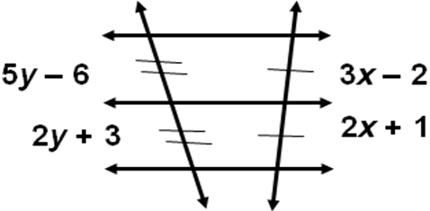

5. Find the value of x + y in the figure?

Lesson 6-6
Find the perimeter of the given triangle.
- ∆UVW, if ∆UVW ~ ∆UVW, MN = 6, NP = 8, MP = 12, and UW = 15.6
- ∆ABC, if ∆ABC ~ ∆DEF, BC = 4.5, EF = 9.9, and the perimeter of ∆DEF is 40.04.
Find x.
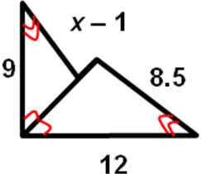
3. 4.

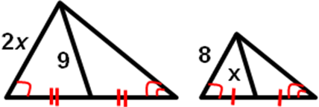

5. Find NO, if ∆MNO ~ ∆RSQ.

